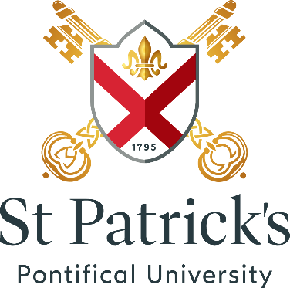
Saint Patrick’s
Pontifical University
Maynooth
Co. Kildare, Ireland

Pontifical University Office
Tel: +353-1-708 3600 Fax: +353-1-708 3441
E-Mail: theology.office@spcm.ie
Web: www.sppu.ie

Postgraduate Modules – Faculty of Philosophy

Female Voices in Religious Philosophy | Mondays 2 – 4 [Top Loftus]
Philosophical Themes in Ancient and Medieval Thought | Tuesdays 2 – 4 [Liturgy Centre 1]
Mind and World | Wednesdays 10 – 12 [Liturgy Centre 1]

For further information, please email Dr Gaven Kerr: gaven.kerr@spcm.ie.

